Experiment 7: Capture Video from Web Camera and Display the Video in Slow Motion and Fast Motion
Aim
To capture live video from the web camera using Python and OpenCV, and display the video in normal speed, slow motion, and fast motion
Software Requirements
- Python 3.x
- OpenCV (cv2)
- Visual Studio Code / PyCharm / Jupyter Notebook
- Webcam
Procedure
- Install the OpenCV library using pip install opencv-python.
- Import the required libraries (cv2 and time).
- Open the default webcam using cv2.VideoCapture(0).
- Check whether the webcam is opened successfully.
- Read video frames continuously using cap.read().
- Display each frame using cv2.imshow().
- Use keyboard keys to change the playback speed:
  - N – Normal Speed
  - S – Slow Motion
  - F – Fast Motion
  - Q – Quit the program
- Control the speed using time.sleep().
- Release the webcam and close all windows after exiting.
Python Code
import cv2
import time
# Open the default webcam
cap = cv2.VideoCapture(0)
if not cap.isOpened():
print("Error: Could not open webcam.")
exit()
print("Controls:")
print("N - Normal Speed")
print("S - Slow Motion")
print("F - Fast Motion")
print("Q - Quit"
mode = "normal
while True:
ret, frame = cap.read(
if not ret:
print("Failed to capture frame.")
break
cv2.imshow("Webcam Video", frame)
key = cv2.waitKey(1) & 0xFF
if key == ord('n'):
mode = "normal"
elif key == ord('s'):
mode = "slow"
elif key == ord('f'):
mode = "fast"
elif key == ord('q'):
break
if mode == "normal":
time.sleep(0.03)
elif mode == "slow":
time.sleep(0.10)
elif mode == "fast":
time.sleep(0.005)
cap.release()
cv2.destroyAllWindows()
Output
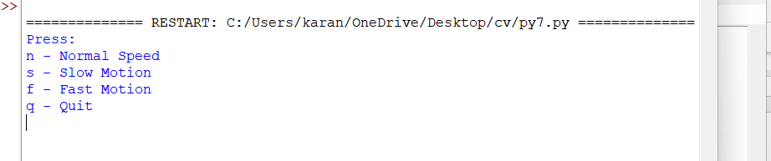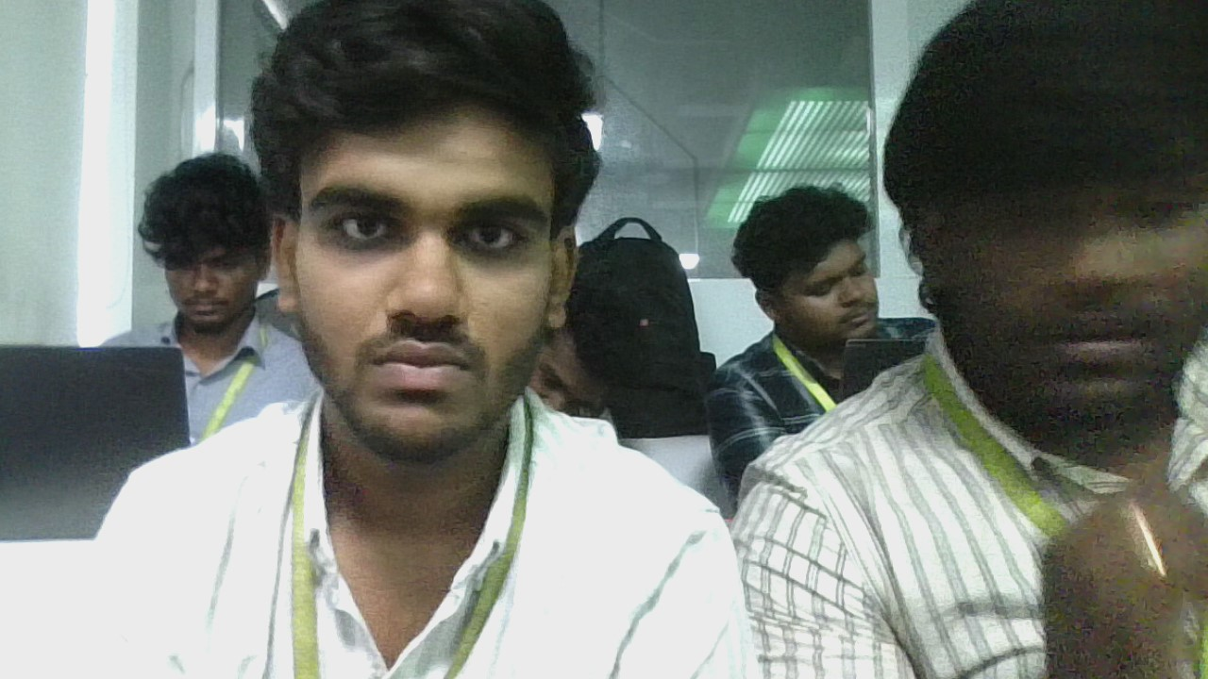

Result
The live video was successfully captured from the web camera using Python and OpenCV. The captured video was displayed in normal, slow-motion, and fast-motion modes based on the user's keyboard input.

